**EVENT MANAGEMENT DATABASE APPLICATION FOR AN ORGANIZATION**

Organizing successful events is no cake walk. Getting people to the event and achieving the mark of making the event successful are two major challenges an event manager faces.

For Big Organizations every day, every hour there is some conference, seminar or meeting being conducted by various departments in the company. These events may be closed (only for employees) or open (for anyone interested). Right from creating the various attributes of an event to continuously monitoring events, managing people, interactions and communication is a very tedious task.

Thus, a Database application which will store all the details of the each and every event occurring in the organization will help to keep a proper track and also involve people participation which will be boon the company as it will help people to bond among themselves and to make work place friendly.

This, Database will help the Organization to analyse their work culture. Employee Relation and employee Satisfaction. How many employees are attending the meetings and conferences also a proper track of events getting organized every year will be recorded for the company’s future reference.

**USE CASE DIAGRAM FOR EVENT MANAGEMENT SYSTEM.**

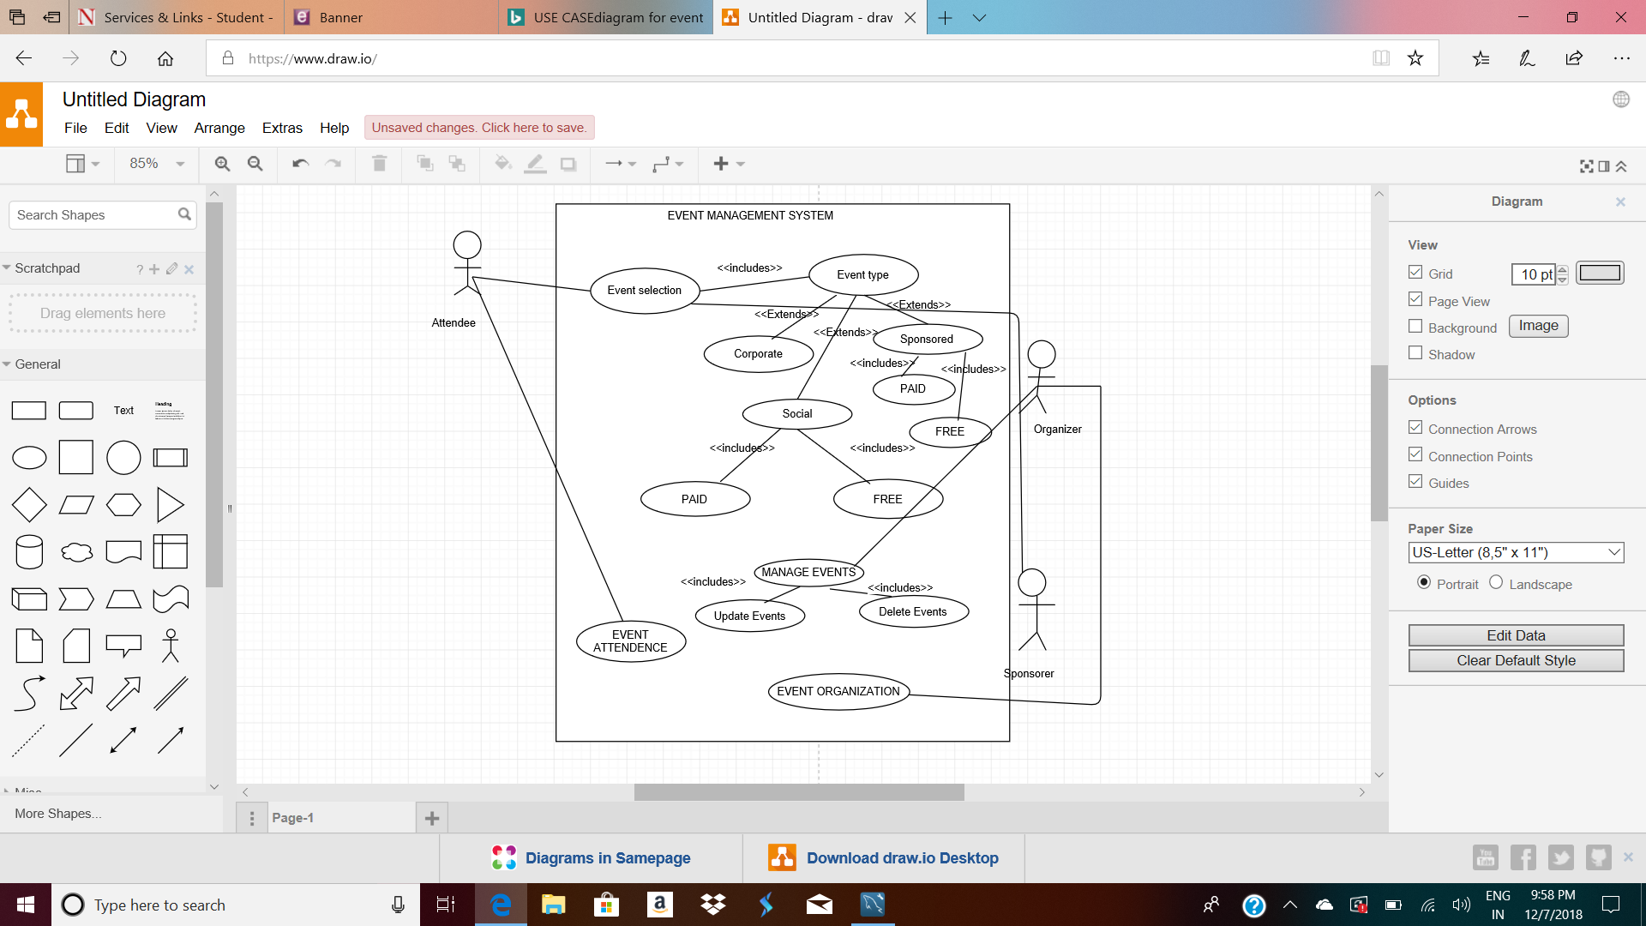

**ENTITY RELATIONSHIP DIAGRAM FOR EVENT MANAGEMENT SYSTEM**:

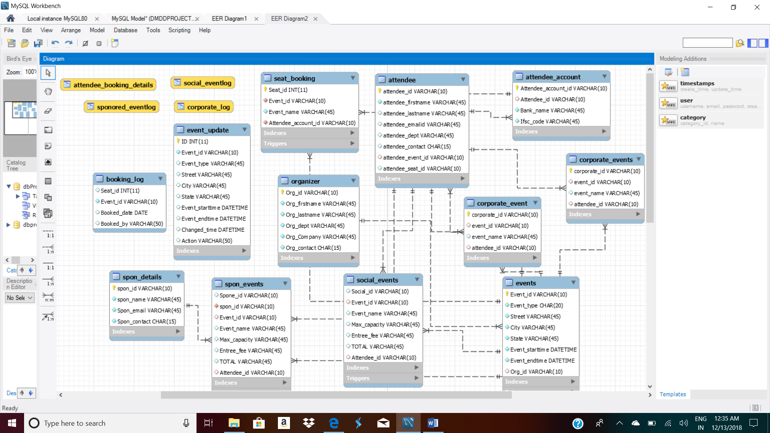

**TRIGGERS:**

**1-TRIGGER FOR CREATING A SEAT BOOKING LOG:**

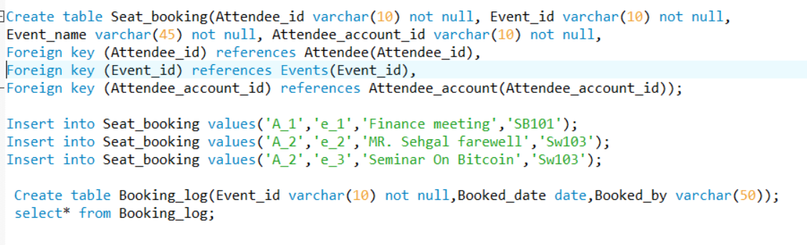DELIMITER //

CREATE TRIGGER tr_Booking_log

AFTER INSERT

ON Seat_Booking FOR EACH ROW

BEGIN

DECLARE vUser varchar(50);

-- Find username of person performing the INSERT into table

SELECT USER() INTO vUser;

-- Insert record into audit table

INSERT INTO Booking_log

( Event_id,

Booked_date,

Booked_by)

VALUES

( new.Event_id,

SYSDATE(),

vUser );

END; //

DELIMITE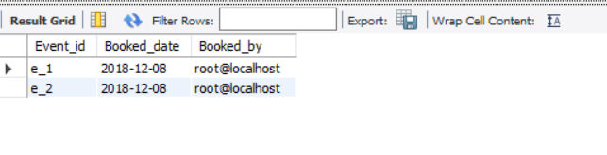

**2-TRIGGER TO CHECK IF THE SEAT IS ALREADY BOOKED OR NOT.**

**Seat_booking Table**

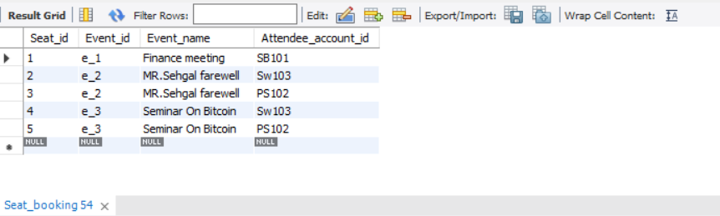

DELIMITER //

Create trigger Check_booking

Before Insert on seat_booking

for Each Row

BEGIN

IF NEW.seat_id in(

select Seat_booking.Seat_id

From Seat_booking

where (NEW.Seat_id = Seat_booking.Seat_id)

)

THEN

SIGNAL SQLSTATE '45000'

SET MESSAGE_TEXT= 'SEAT IS ALREADY BOOKED FOR THIS EVENT';

END IF;

END; //

DELIMITER ;

If the attendee tries to Book the seat with the same seat_id he should receive a message saying that the seat is already booked.



3- TRIGGER THAT STORES OLD VALUES WHEN THE EVENT IS UPDATE WITH THE TIME OF MODIFICATION.

Delimiter //

Create trigger tr_Event_update

before update on Events

for each row

begin

insert into Event_update

set action ="UPDATE",

Event_id = old.Event_id,

Event_type=old.event_type,

Street=old.street,

city= old.city,

state= old.state,

Event_starttime=old.event_starttime,

Event_endtime=old.Event_endtime,

Changed_time=Now();

END; //

TABLE THAT STORES OLD RECORDS:

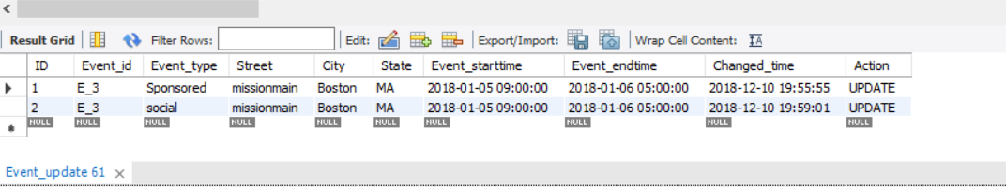

EVENTS TABLE WITH UPDATE VALUES:

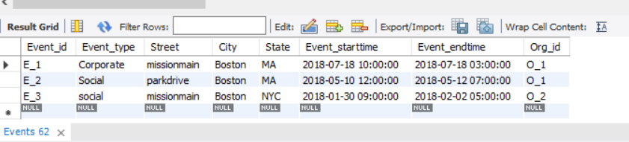

**JOIN QUERY TO BE STORED AS VIEW :**

1. **VIEW FOR CORPORATE EVENTS**

CREATE VIEW CORPORATE_LOG AS

SELECT organizer.Org_lastname,Org_firstname,organizer.Org_contact, Events.event_type,Events.street AS EVENTSTREET,

Events.city AS EVENTCITY,

Events.state as EVENTSTATE, Events.event_starttime AS STARTTIME,corporate_event.corporate_id,

CORPORATE_event.EVENT_NAME as CORPORATE_EVENT

FROM Organizer

INNER JOIN EVENTS ON organizer.org_id= events.Org_id

INNER JOIN CORPORATE_EVENT ON CORPORATE_event.EVENT_ID= EVENTs.EVENT_ID;

SELECT ORG_LASTNAME,ORG_FIRSTNAME,ORG_CONTACT,EVENT_TYPE,

EVENTSTREET,EVENTCITY,EVENTSTATE,STARTTIME,CORPORATE_ID,CORPORATE_EVENT FROM CORPORATE_LOG;

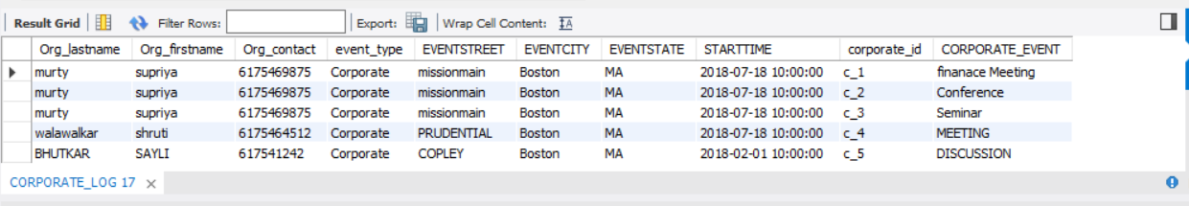

1. **VIEW FOR SOCIAL EVENTS**

CREATE VIEW SOCIAL_EVENTLOG AS

SELECT ORGANIZER.ORG_LASTNAME,ORGANIZER.ORG_FIRSTNAME,ORGANIZER.ORG_CONTACT,EVENTS.EVENT_ID, EVENTS.EVENT_TYPE, EVENTS.EVENT_STARTTIME,

SOCIAL_EVENTS.SOCIAL_ID,SOCIAL_EVENTS.EVENT_NAME AS SOCIAL_EVENT,

SOCIAL_EVENTS.MAX_CAPACITY AS MAXCAPACITY_FOR_SOCIAL_EVENTS,SOCIAL_EVENTS.ATTENDEE_ID

FROM ORGANIZER

INNER JOIN EVENTS ON organizer.org_id= events.Org_id

INNER JOIN SOCIAL_EVENTS ON EVENTS.EVENT_ID=SOCIAL_EVENTS.EVENT_ID

SELECT ORG_LASTNAME, ORG_FIRSTNAME,ORG_CONTACT,EVENT_TYPE,EVENT_ID,

EVENT_STARTTIME, SOCIAL_ID,SOCIAL_EVENT,MAXCAPACITY_FOR_SOCIAL_EVENTS FROM SOCIAL_EVENTLOG;

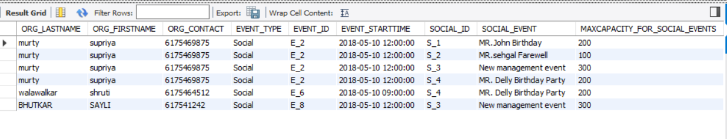

1. **VIEW FOR SPONSORED EVENTS**

CREATE VIEW SPONORED_EVENTLOG AS

SELECT ORGANIZER.ORG_LASTNAME,ORGANIZER.ORG_FIRSTNAME,ORGANIZER.ORG_CONTACT,EVENTS.EVENT_ID, EVENTS.EVENT_TYPE, EVENTS.EVENT_STARTTIME,

SPON_EVENTS.SPONE_ID,SPON_EVENTS.EVENT_NAME AS SPON_EVENT,

SPON_EVENTS.MAX_CAPACITY AS MAXCAPACITY_FOR_SPONORED_EVENTS,SPON_EVENTS.ATTENDEE_ID

FROM ORGANIZER

INNER JOIN EVENTS ON organizer.org_id= events.Org_id

INNER JOIN SPON_EVENTS ON EVENTS.EVENT_ID=SPON_EVENTS.EVENT_ID;

SELECT ORG_LASTNAME, ORG_FIRSTNAME,ORG_CONTACT,EVENT_TYPE,EVENT_ID,

EVENT_STARTTIME, SPON_ID,SOCIAL_EVENT,MAXCAPACITY_FOR_SPON_EVENTS FROM SPONORED_EVENTLOG;

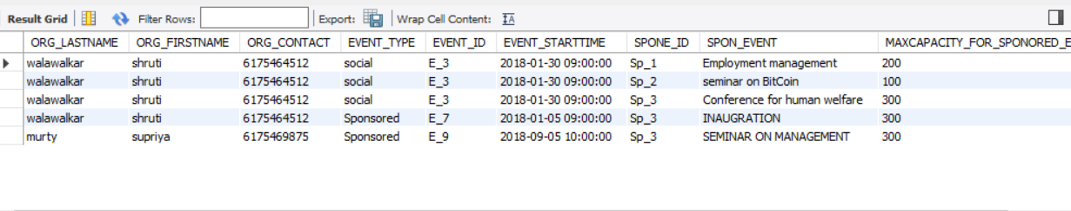

1. **VIEW ATTENDEE_BOOKING_BOOKING DETAILS**

CREATE VIEW attendee_booking_details as

select attendee.attendee_firstname as FIRSTNAME,attendee.attendee_lastname as LASTNAME, attendee.attendee_emailid as EMAIL_ID,attendee.attendee_contact AS CONTACT,

attendee_account.attendee_id AS ID,attendee_account.bank_name AS BANK_NAME,attendee_account.ifsc_code AS IFSC_CODE,

seat_booking.seat_id as SEAT_ID, seat_booking.EVENT_NAME

FROM ATTENDEE

INNER JOIN ATTENDEE_ACCOUNT ON attendee.attendee_id=attendee_account.attendee_id

INNER JOIN SEAT_BOOKING ON attendee_account.attendee_account_id=seat_booking.attendee_account_id;

select FIRSTNAME, LASTNAME, EMAIL_ID, ID,BANK_NAME,IFSC_CODE, SEAT_ID,EVENT_NAME from attendee_booking_details;

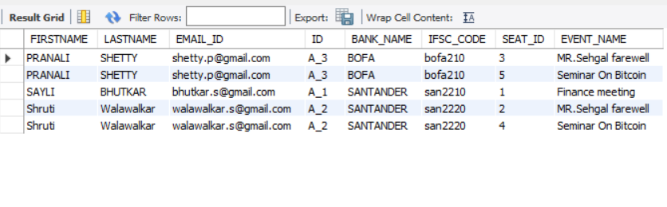TRIGGERS TO CALCULATE TOTAL IN SOCIAL AND SPONSORED EVENTS:

DELIMITER //

CREATE trigger t1

before insert on social_events

FOR EACH ROW

BEGIN

SET NEW.TOTAL= NEW.MAX_CAPACITY*NEW.ENTREE_FEE;

END;

//

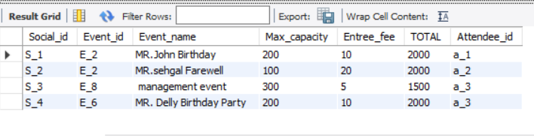

DELIMITER //

CREATE TRIGGER T2

BEFORE INSERT ON SPON_EVENTS

FOR EACH ROW

BEGIN

SET NEW.TOTAL= NEW.MAX_CAPACITY*NEW.ENTREE_FEE;

END;

//

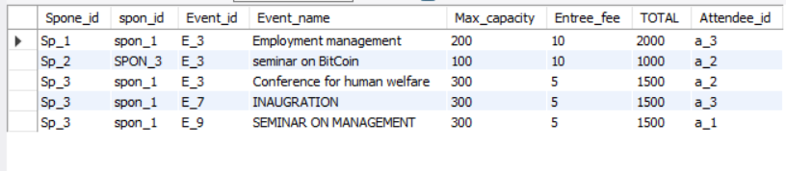

**STORED PROCEDURES:**

SOCIAL_EVENTS

delimiter //

create procedure entree_fee_increment(in percent int, in id varchar(10))

begin

update social_events

set entree_fee= entree_fee + (entree_fee* percent/100)

where social_id= id;

update social_events

set total= max_capacity*entree_fee

where social_id=id;

end;

//

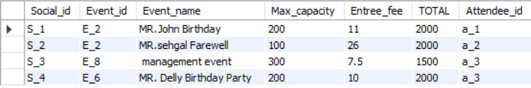

**After update:**

call entree_fee_increment (8,'s_1');

call entree_fee_increment (30,'s_3');

call entree_fee_increment (4,'s_4');

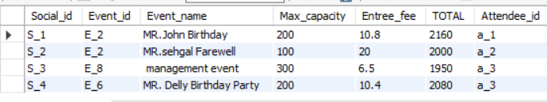

SPONSORED_EVENTS

delimiter //

create procedure entree_fee_increment1(in percent int, in id varchar(10))

begin

update spon_events

set entree_fee= entree_fee + (entree_fee* percent/100)

where spone_id= id;

update spon_events

set total= max_capacity*entree_fee

where spon_id=id;

end;

//

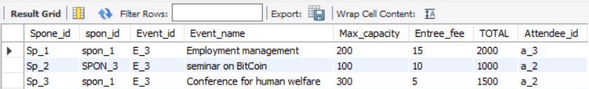

call entree_fee_increment1(10,'sp_1')

call entree_fee_increment1 (30,'sp_2');

call entree_fee_increment1 (50,'sp_3');

After update

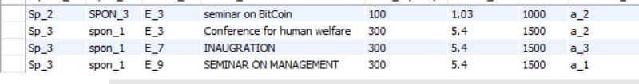

**SQL DUMP FILE**

CREATE DATABASE IF NOT EXISTS `dbproject` /*!40100 DEFAULT CHARACTER SET utf8mb4 COLLATE utf8mb4_0900_ai_ci */;

USE `dbproject`;

-- MySQL dump 10.13 Distrib 8.0.13, for Win64 (x86_64)

--

-- Host: localhost Database: dbproject

-- ------------------------------------------------------

-- Server version 8.0.13

/*!40101 SET @OLD_CHARACTER_SET_CLIENT=@@CHARACTER_SET_CLIENT */;

/*!40101 SET @OLD_CHARACTER_SET_RESULTS=@@CHARACTER_SET_RESULTS */;

/*!40101 SET @OLD_COLLATION_CONNECTION=@@COLLATION_CONNECTION */;

SET NAMES utf8 ;

/*!40103 SET @OLD_TIME_ZONE=@@TIME_ZONE */;

/*!40103 SET TIME_ZONE='+00:00' */;

/*!40014 SET @OLD_UNIQUE_CHECKS=@@UNIQUE_CHECKS, UNIQUE_CHECKS=0 */;

/*!40014 SET @OLD_FOREIGN_KEY_CHECKS=@@FOREIGN_KEY_CHECKS, FOREIGN_KEY_CHECKS=0 */;

/*!40101 SET @OLD_SQL_MODE=@@SQL_MODE, SQL_MODE='NO_AUTO_VALUE_ON_ZERO' */;

/*!40111 SET @OLD_SQL_NOTES=@@SQL_NOTES, SQL_NOTES=0 */;

--

-- Table structure for table `attendee`

--

DROP TABLE IF EXISTS `attendee`;

/*!40101 SET @saved_cs_client = @@character_set_client */;

SET character_set_client = utf8mb4 ;

CREATE TABLE `attendee` (

`attendee_id` varchar(10) NOT NULL,

`attendee_firstname` varchar(45) NOT NULL,

`attendee_lastname` varchar(45) DEFAULT NULL,

`attendee_emailid` varchar(45) DEFAULT NULL,

`attendee_dept` varchar(45) DEFAULT NULL,

`attendee_contact` char(15) DEFAULT NULL,

`attendee_event_id` varchar(10) DEFAULT NULL,

`attendee_seat_id` varchar(10) DEFAULT NULL,

PRIMARY KEY (`attendee_id`),

KEY `attendee_event_id` (`attendee_event_id`),

CONSTRAINT `attendee_ibfk_1` FOREIGN KEY (`attendee_event_id`) REFERENCES `events` (`event_id`)

) ENGINE=InnoDB DEFAULT CHARSET=utf8mb4 COLLATE=utf8mb4_0900_ai_ci;

/*!40101 SET character_set_client = @saved_cs_client */;

--

-- Dumping data for table `attendee`

--

LOCK TABLES `attendee` WRITE;

/*!40000 ALTER TABLE `attendee` DISABLE KEYS */;

INSERT INTO `attendee` VALUES ('A_1','SAYLI','BHUTKAR','bhutkar.s@gmail.com','accounts','6174589632','e_1','1'),('A_2','Shruti','Walawalkar','walawalkar.s@gmail.com','HR','6174589631','e_2','2'),('A_3','PRANALI','SHETTY','shetty.p@gmail.com','FINANCE','6174589612','e_8','3'),('A_4','shivani','kulkarni','kulkarni.s@gmail.com','accounts','6174587854','e_6','4'),('A_5','ashok','Sharma','sharma@gmail.com','FINANCE','6174545112','e_7','5');

/*!40000 ALTER TABLE `attendee` ENABLE KEYS */;

UNLOCK TABLES;

--

-- Table structure for table `attendee_account`

--

DROP TABLE IF EXISTS `attendee_account`;

/*!40101 SET @saved_cs_client = @@character_set_client */;

SET character_set_client = utf8mb4 ;

CREATE TABLE `attendee_account` (

`Attendee_account_id` varchar(10) NOT NULL,

`Attendee_id` varchar(10) DEFAULT NULL,

`Bank_name` varchar(45) NOT NULL,

`Ifsc_code` varchar(45) NOT NULL,

PRIMARY KEY (`Attendee_account_id`),

KEY `Attendee_id` (`Attendee_id`),

CONSTRAINT `attendee_account_ibfk_1` FOREIGN KEY (`Attendee_id`) REFERENCES `attendee` (`attendee_id`)

) ENGINE=InnoDB DEFAULT CHARSET=utf8mb4 COLLATE=utf8mb4_0900_ai_ci;

/*!40101 SET character_set_client = @saved_cs_client */;

--

-- Dumping data for table `attendee_account`

--

LOCK TABLES `attendee_account` WRITE;

/*!40000 ALTER TABLE `attendee_account` DISABLE KEYS */;

INSERT INTO `attendee_account` VALUES ('as105','a_5','discover','dis1001'),('PS102','A_3','BOFA','bofa210'),('SB101','A_1','SANTANDER','san2210'),('sk104','a_4','bofa','bofa1000'),('SW103','A_2','SANTANDER','san2220');

/*!40000 ALTER TABLE `attendee_account` ENABLE KEYS */;

UNLOCK TABLES;

--

-- Temporary view structure for view `attendee_booking_details`

--

DROP TABLE IF EXISTS `attendee_booking_details`;

/*!50001 DROP VIEW IF EXISTS `attendee_booking_details`*/;

SET @saved_cs_client = @@character_set_client;

SET character_set_client = utf8mb4;

/*!50001 CREATE VIEW `attendee_booking_details` AS SELECT

1 AS `FIRSTNAME`,

1 AS `LASTNAME`,

1 AS `EMAIL_ID`,

1 AS `CONTACT`,

1 AS `ID`,

1 AS `BANK_NAME`,

1 AS `IFSC_CODE`,

1 AS `SEAT_ID`,

1 AS `EVENT_NAME`*/;

SET character_set_client = @saved_cs_client;

--

-- Table structure for table `booking_log`

--

DROP TABLE IF EXISTS `booking_log`;

/*!40101 SET @saved_cs_client = @@character_set_client */;

SET character_set_client = utf8mb4 ;

CREATE TABLE `booking_log` (

`Seat_id` int(11) DEFAULT NULL,

`Event_id` varchar(10) NOT NULL,

`Booked_date` date DEFAULT NULL,

`Booked_by` varchar(50) DEFAULT NULL

) ENGINE=InnoDB DEFAULT CHARSET=utf8mb4 COLLATE=utf8mb4_0900_ai_ci;

/*!40101 SET character_set_client = @saved_cs_client */;

--

-- Dumping data for table `booking_log`

--

LOCK TABLES `booking_log` WRITE;

/*!40000 ALTER TABLE `booking_log` DISABLE KEYS */;

INSERT INTO `booking_log` VALUES (4,'e_3','2018-12-08','root@localhost'),(5,'e_3','2018-12-08','root@localhost'),(6,'e_5','2018-12-13','root@localhost'),(7,'e_4','2018-12-13','root@localhost');

/*!40000 ALTER TABLE `booking_log` ENABLE KEYS */;

UNLOCK TABLES;

--

-- Table structure for table `corporate_event`

--

DROP TABLE IF EXISTS `corporate_event`;

/*!40101 SET @saved_cs_client = @@character_set_client */;

SET character_set_client = utf8mb4 ;

CREATE TABLE `corporate_event` (

`corporate_id` varchar(10) NOT NULL,

`event_id` varchar(10) DEFAULT NULL,

`event_name` varchar(45) DEFAULT NULL,

`attendee_id` varchar(10) DEFAULT NULL,

PRIMARY KEY (`corporate_id`),

KEY `event_id` (`event_id`),

KEY `attendee_id` (`attendee_id`),

CONSTRAINT `corporate_event_ibfk_1` FOREIGN KEY (`event_id`) REFERENCES `events` (`event_id`),

CONSTRAINT `corporate_event_ibfk_2` FOREIGN KEY (`attendee_id`) REFERENCES `attendee` (`attendee_id`)

) ENGINE=InnoDB DEFAULT CHARSET=utf8mb4 COLLATE=utf8mb4_0900_ai_ci;

/*!40101 SET character_set_client = @saved_cs_client */;

--

-- Dumping data for table `corporate_event`

--

LOCK TABLES `corporate_event` WRITE;

/*!40000 ALTER TABLE `corporate_event` DISABLE KEYS */;

INSERT INTO `corporate_event` VALUES ('c_1','e_1','finanace Meeting','a_1'),('c_2','e_1','Conference','a_2'),('c_3','e_4','Seminar','a_1'),('c_4','e_4','MEETING','a_2'),('c_5','e_5','DISCUSSION','a_1');

/*!40000 ALTER TABLE `corporate_event` ENABLE KEYS */;

UNLOCK TABLES;

--

-- Table structure for table `corporate_events`

--

DROP TABLE IF EXISTS `corporate_events`;

/*!40101 SET @saved_cs_client = @@character_set_client */;

SET character_set_client = utf8mb4 ;

CREATE TABLE `corporate_events` (

`corporate_id` varchar(10) NOT NULL,

`event_id` varchar(10) DEFAULT NULL,

`event_name` varchar(45) DEFAULT NULL,

`attendee_id` varchar(10) DEFAULT NULL,

PRIMARY KEY (`corporate_id`),

KEY `event_id` (`event_id`),

KEY `attendee_id` (`attendee_id`),

CONSTRAINT `corporate_events_ibfk_1` FOREIGN KEY (`event_id`) REFERENCES `events` (`event_id`),

CONSTRAINT `corporate_events_ibfk_2` FOREIGN KEY (`attendee_id`) REFERENCES `attendee` (`attendee_id`)

) ENGINE=InnoDB DEFAULT CHARSET=utf8mb4 COLLATE=utf8mb4_0900_ai_ci;

/*!40101 SET character_set_client = @saved_cs_client */;

--

-- Dumping data for table `corporate_events`

--

LOCK TABLES `corporate_events` WRITE;

/*!40000 ALTER TABLE `corporate_events` DISABLE KEYS */;

/*!40000 ALTER TABLE `corporate_events` ENABLE KEYS */;

UNLOCK TABLES;

--

-- Temporary view structure for view `corporate_log`

--

DROP TABLE IF EXISTS `corporate_log`;

/*!50001 DROP VIEW IF EXISTS `corporate_log`*/;

SET @saved_cs_client = @@character_set_client;

SET character_set_client = utf8mb4;

/*!50001 CREATE VIEW `corporate_log` AS SELECT

1 AS `Org_lastname`,

1 AS `Org_firstname`,

1 AS `Org_contact`,

1 AS `event_type`,

1 AS `EVENTSTREET`,

1 AS `EVENTCITY`,

1 AS `EVENTSTATE`,

1 AS `STARTTIME`,

1 AS `corporate_id`,

1 AS `CORPORATE_EVENT`*/;

SET character_set_client = @saved_cs_client;

--

-- Table structure for table `event_update`

--

DROP TABLE IF EXISTS `event_update`;

/*!40101 SET @saved_cs_client = @@character_set_client */;

SET character_set_client = utf8mb4 ;

CREATE TABLE `event_update` (

`ID` int(11) NOT NULL AUTO_INCREMENT,

`Event_id` varchar(10) NOT NULL,

`Event_type` varchar(45) DEFAULT NULL,

`Street` varchar(45) DEFAULT NULL,

`City` varchar(45) DEFAULT NULL,

`State` varchar(45) DEFAULT NULL,

`Event_starttime` datetime DEFAULT NULL,

`Event_endtime` datetime DEFAULT NULL,

`Changed_time` datetime DEFAULT NULL,

`Action` varchar(50) DEFAULT NULL,

PRIMARY KEY (`ID`)

) ENGINE=InnoDB AUTO_INCREMENT=7 DEFAULT CHARSET=utf8mb4 COLLATE=utf8mb4_0900_ai_ci;

/*!40101 SET character_set_client = @saved_cs_client */;

--

-- Dumping data for table `event_update`

--

LOCK TABLES `event_update` WRITE;

/*!40000 ALTER TABLE `event_update` DISABLE KEYS */;

INSERT INTO `event_update` VALUES (1,'E_3','Sponsored','missionmain','Boston','MA','2018-01-05 09:00:00','2018-01-06 05:00:00','2018-12-10 19:55:55','UPDATE'),(2,'E_3','social','missionmain','Boston','MA','2018-01-05 09:00:00','2018-01-06 05:00:00','2018-12-10 19:59:01','UPDATE'),(3,'E_6','Social','parkdrive','Boston','MA','2018-05-10 09:00:00','2018-10-12 12:00:00','2018-12-12 23:48:24','UPDATE'),(4,'E_6','Social','parkdrive','Boston','MA','2018-05-10 09:00:00','2018-10-12 12:00:00','2018-12-12 23:48:24','DELETE'),(5,'E_6','Social','parkdrive','Boston','MA','2018-08-08 10:00:00','2018-10-12 12:00:00','2018-12-12 23:49:24','UPDATE'),(6,'E_6','Social','parkdrive','Boston','MA','2018-08-08 10:00:00','2018-10-12 12:00:00','2018-12-12 23:49:24','DELETE');

/*!40000 ALTER TABLE `event_update` ENABLE KEYS */;

UNLOCK TABLES;

--

-- Table structure for table `events`

--

DROP TABLE IF EXISTS `events`;

/*!40101 SET @saved_cs_client = @@character_set_client */;

SET character_set_client = utf8mb4 ;

CREATE TABLE `events` (

`Event_id` varchar(10) NOT NULL,

`Event_type` char(20) NOT NULL,

`Street` varchar(45) NOT NULL,

`City` varchar(45) NOT NULL,

`State` varchar(45) NOT NULL,

`Event_starttime` datetime NOT NULL,

`Event_endtime` datetime NOT NULL,

`Org_id` varchar(10) DEFAULT NULL,

PRIMARY KEY (`Event_id`),

KEY `org_id_idx` (`Org_id`),

CONSTRAINT `org_id` FOREIGN KEY (`Org_id`) REFERENCES `organizer` (`org_id`)

) ENGINE=InnoDB DEFAULT CHARSET=utf8mb4 COLLATE=utf8mb4_0900_ai_ci;

/*!40101 SET character_set_client = @saved_cs_client */;

--

-- Dumping data for table `events`

--

LOCK TABLES `events` WRITE;

/*!40000 ALTER TABLE `events` DISABLE KEYS */;

INSERT INTO `events` VALUES ('E_1','Corporate','missionmain','Boston','MA','2018-07-18 10:00:00','2018-07-18 03:00:00','O_1'),('E_2','Social','parkdrive','Boston','MA','2018-05-10 12:00:00','2018-05-12 07:00:00','O_1'),('E_3','social','missionmain','Boston','NYC','2018-01-30 09:00:00','2018-02-02 05:00:00','O_2'),('E_4','Corporate','PRUDENTIAL','Boston','MA','2018-07-18 10:00:00','2018-07-18 03:00:00','O_2'),('E_5','Corporate','COPLEY','Boston','MA','2018-02-01 10:00:00','2018-02-05 05:00:00','O_3'),('E_6','Social','parkdrive','Boston','MA','2018-08-08 10:00:00','2018-08-10 12:00:00','O_2'),('E_7','Sponsored','PRUDENTIAL','Boston','MA','2018-01-05 09:00:00','2018-01-06 05:00:00','O_2'),('E_8','Social','COPLEY','Boston','MA','2018-05-10 12:00:00','2018-05-12 07:00:00','O_3'),('E_9','Sponsored','MISSION HILL','Boston','MA','2018-09-05 10:00:00','2018-09-15 05:00:00','O_1');

/*!40000 ALTER TABLE `events` ENABLE KEYS */;

UNLOCK TABLES;

/*!50003 SET @saved_cs_client = @@character_set_client */ ;

/*!50003 SET @saved_cs_results = @@character_set_results */ ;

/*!50003 SET @saved_col_connection = @@collation_connection */ ;

/*!50003 SET character_set_client = utf8mb4 */ ;

/*!50003 SET character_set_results = utf8mb4 */ ;

/*!50003 SET collation_connection = utf8mb4_0900_ai_ci */ ;

/*!50003 SET @saved_sql_mode = @@sql_mode */ ;

/*!50003 SET sql_mode = 'STRICT_TRANS_TABLES,NO_ENGINE_SUBSTITUTION' */ ;

DELIMITER ;;

/*!50003 CREATE*/ /*!50017 DEFINER=`root`@`localhost`*/ /*!50003 TRIGGER `tr_Event_update` BEFORE UPDATE ON `events` FOR EACH ROW begin

insert into Event_update

set action ="UPDATE",

Event_id = old.Event_id,

Event_type=old.event_type,

Street=old.street,

city= old.city,

state= old.state,

Event_starttime=old.event_starttime,

Event_endtime=old.Event_endtime,

Changed_time=Now();

END */;;

DELIMITER ;

/*!50003 SET sql_mode = @saved_sql_mode */ ;

/*!50003 SET character_set_client = @saved_cs_client */ ;

/*!50003 SET character_set_results = @saved_cs_results */ ;

/*!50003 SET collation_connection = @saved_col_connection */ ;

/*!50003 SET @saved_cs_client = @@character_set_client */ ;

/*!50003 SET @saved_cs_results = @@character_set_results */ ;

/*!50003 SET @saved_col_connection = @@collation_connection */ ;

/*!50003 SET character_set_client = utf8mb4 */ ;

/*!50003 SET character_set_results = utf8mb4 */ ;

/*!50003 SET collation_connection = utf8mb4_0900_ai_ci */ ;

/*!50003 SET @saved_sql_mode = @@sql_mode */ ;

/*!50003 SET sql_mode = 'STRICT_TRANS_TABLES,NO_ENGINE_SUBSTITUTION' */ ;

DELIMITER ;;

/*!50003 CREATE*/ /*!50017 DEFINER=`root`@`localhost`*/ /*!50003 TRIGGER `tr_Event_DELETE` BEFORE UPDATE ON `events` FOR EACH ROW begin

insert into Event_update

set action ="DELETE",

Event_id = old.Event_id,

Event_type=old.event_type,

Street=old.street,

city= old.city,

state= old.state,

Event_starttime=old.event_starttime,

Event_endtime=old.Event_endtime,

Changed_time=Now();

END */;;

DELIMITER ;

/*!50003 SET sql_mode = @saved_sql_mode */ ;

/*!50003 SET character_set_client = @saved_cs_client */ ;

/*!50003 SET character_set_results = @saved_cs_results */ ;

/*!50003 SET collation_connection = @saved_col_connection */ ;

--

-- Table structure for table `organizer`

--

DROP TABLE IF EXISTS `organizer`;

/*!40101 SET @saved_cs_client = @@character_set_client */;

SET character_set_client = utf8mb4 ;

CREATE TABLE `organizer` (

`Org_id` varchar(10) NOT NULL,

`Org_firstname` varchar(45) NOT NULL,

`Org_lastname` varchar(45) NOT NULL,

`Org_dept` varchar(45) NOT NULL,

`Org_Company` varchar(45) NOT NULL,

`Org_contact` char(15) NOT NULL,

PRIMARY KEY (`Org_id`)

) ENGINE=InnoDB DEFAULT CHARSET=utf8mb4 COLLATE=utf8mb4_0900_ai_ci;

/*!40101 SET character_set_client = @saved_cs_client */;

--

-- Dumping data for table `organizer`

--

LOCK TABLES `organizer` WRITE;

/*!40000 ALTER TABLE `organizer` DISABLE KEYS */;

INSERT INTO `organizer` VALUES ('o_1','supriya','murty','HR','L&T','6175469875'),('o_2','shruti','walawalkar','Accounts','L&T','6175464512'),('o_3','SAYLI','BHUTKAR','FINANCE','L&T','617541242');

/*!40000 ALTER TABLE `organizer` ENABLE KEYS */;

UNLOCK TABLES;

--

-- Table structure for table `seat_booking`

--

DROP TABLE IF EXISTS `seat_booking`;

/*!40101 SET @saved_cs_client = @@character_set_client */;

SET character_set_client = utf8mb4 ;

CREATE TABLE `seat_booking` (

`Seat_id` int(11) NOT NULL,

`Event_id` varchar(10) NOT NULL,

`Event_name` varchar(45) NOT NULL,

`Attendee_account_id` varchar(10) NOT NULL,

PRIMARY KEY (`Seat_id`),

KEY `Event_id` (`Event_id`),

KEY `Attendee_account_id` (`Attendee_account_id`),

CONSTRAINT `seat_booking_ibfk_1` FOREIGN KEY (`Event_id`) REFERENCES `events` (`event_id`),

CONSTRAINT `seat_booking_ibfk_2` FOREIGN KEY (`Attendee_account_id`) REFERENCES `attendee_account` (`attendee_account_id`)

) ENGINE=InnoDB DEFAULT CHARSET=utf8mb4 COLLATE=utf8mb4_0900_ai_ci;

/*!40101 SET character_set_client = @saved_cs_client */;

--

-- Dumping data for table `seat_booking`

--

LOCK TABLES `seat_booking` WRITE;

/*!40000 ALTER TABLE `seat_booking` DISABLE KEYS */;

INSERT INTO `seat_booking` VALUES (1,'e_1','Finance meeting','SB101'),(2,'e_2','MR.Sehgal farewell','Sw103'),(3,'e_2','MR.Sehgal farewell','PS102'),(4,'e_3','Seminar On Bitcoin','Sw103'),(5,'e_3','Seminar On Bitcoin','PS102'),(6,'e_5','conference','sk104'),(7,'e_4','meeting','PS102');

/*!40000 ALTER TABLE `seat_booking` ENABLE KEYS */;

UNLOCK TABLES;

/*!50003 SET @saved_cs_client = @@character_set_client */ ;

/*!50003 SET @saved_cs_results = @@character_set_results */ ;

/*!50003 SET @saved_col_connection = @@collation_connection */ ;

/*!50003 SET character_set_client = utf8mb4 */ ;

/*!50003 SET character_set_results = utf8mb4 */ ;

/*!50003 SET collation_connection = utf8mb4_0900_ai_ci */ ;

/*!50003 SET @saved_sql_mode = @@sql_mode */ ;

/*!50003 SET sql_mode = 'STRICT_TRANS_TABLES,NO_ENGINE_SUBSTITUTION' */ ;

DELIMITER ;;

/*!50003 CREATE*/ /*!50017 DEFINER=`root`@`localhost`*/ /*!50003 TRIGGER `Check_booking` BEFORE INSERT ON `seat_booking` FOR EACH ROW BEGIN

IF NEW.seat_id in(

select Seat_booking.Seat_id

From Seat_booking

where (NEW.Seat_id = Seat_booking.Seat_id)

)

THEN

SIGNAL SQLSTATE '45000'

SET MESSAGE_TEXT= 'SEAT IS ALREADY BOOKED FOR THIS EVENT';

END IF;

END */;;

DELIMITER ;

/*!50003 SET sql_mode = @saved_sql_mode */ ;

/*!50003 SET character_set_client = @saved_cs_client */ ;

/*!50003 SET character_set_results = @saved_cs_results */ ;

/*!50003 SET collation_connection = @saved_col_connection */ ;

/*!50003 SET @saved_cs_client = @@character_set_client */ ;

/*!50003 SET @saved_cs_results = @@character_set_results */ ;

/*!50003 SET @saved_col_connection = @@collation_connection */ ;

/*!50003 SET character_set_client = utf8mb4 */ ;

/*!50003 SET character_set_results = utf8mb4 */ ;

/*!50003 SET collation_connection = utf8mb4_0900_ai_ci */ ;

/*!50003 SET @saved_sql_mode = @@sql_mode */ ;

/*!50003 SET sql_mode = 'STRICT_TRANS_TABLES,NO_ENGINE_SUBSTITUTION' */ ;

DELIMITER ;;

/*!50003 CREATE*/ /*!50017 DEFINER=`root`@`localhost`*/ /*!50003 TRIGGER `tr_1_Booking_log` AFTER INSERT ON `seat_booking` FOR EACH ROW BEGIN

DECLARE vUser varchar(50);

-- Find username of person performing the INSERT into table

SELECT USER() INTO vUser;

-- Insert record into audit table

INSERT INTO Booking_log

( Seat_id,

Event_id,

Booked_date,

Booked_by)

VALUES

( new.Seat_id,

new.Event_id,

SYSDATE(),

vUser );

END */;;

DELIMITER ;

/*!50003 SET sql_mode = @saved_sql_mode */ ;

/*!50003 SET character_set_client = @saved_cs_client */ ;

/*!50003 SET character_set_results = @saved_cs_results */ ;

/*!50003 SET collation_connection = @saved_col_connection */ ;

--

-- Temporary view structure for view `social_eventlog`

--

DROP TABLE IF EXISTS `social_eventlog`;

/*!50001 DROP VIEW IF EXISTS `social_eventlog`*/;

SET @saved_cs_client = @@character_set_client;

SET character_set_client = utf8mb4;

/*!50001 CREATE VIEW `social_eventlog` AS SELECT

1 AS `ORG_LASTNAME`,

1 AS `ORG_FIRSTNAME`,

1 AS `ORG_CONTACT`,

1 AS `EVENT_ID`,

1 AS `EVENT_TYPE`,

1 AS `EVENT_STARTTIME`,

1 AS `SOCIAL_ID`,

1 AS `SOCIAL_EVENT`,

1 AS `MAXCAPACITY_FOR_SOCIAL_EVENTS`,

1 AS `ATTENDEE_ID`*/;

SET character_set_client = @saved_cs_client;

--

-- Table structure for table `social_events`

--

DROP TABLE IF EXISTS `social_events`;

/*!40101 SET @saved_cs_client = @@character_set_client */;

SET character_set_client = utf8mb4 ;

CREATE TABLE `social_events` (

`Social_id` varchar(10) DEFAULT NULL,

`Event_id` varchar(10) DEFAULT NULL,

`Event_name` varchar(45) DEFAULT NULL,

`Max_capacity` varchar(45) DEFAULT NULL,

`Entree_fee` varchar(45) DEFAULT NULL,

`TOTAL` varchar(45) DEFAULT NULL,

`Attendee_id` varchar(10) DEFAULT NULL,

KEY `Event_id` (`Event_id`),

KEY `Attendee_id` (`Attendee_id`),

CONSTRAINT `social_events_ibfk_1` FOREIGN KEY (`Event_id`) REFERENCES `events` (`event_id`),

CONSTRAINT `social_events_ibfk_2` FOREIGN KEY (`Attendee_id`) REFERENCES `attendee` (`attendee_id`)

) ENGINE=InnoDB DEFAULT CHARSET=utf8mb4 COLLATE=utf8mb4_0900_ai_ci;

/*!40101 SET character_set_client = @saved_cs_client */;

--

-- Dumping data for table `social_events`

--

LOCK TABLES `social_events` WRITE;

/*!40000 ALTER TABLE `social_events` DISABLE KEYS */;

INSERT INTO `social_events` VALUES ('S_1','E_2','MR.John Birthday','200','10.8','2160','a_1'),('S_2','E_2','MR.sehgal Farewell','100','20','2000','a_2'),('S_3','E_8',' management event','300','6.5','1950','a_3'),('S_4','E_6','MR. Delly Birthday Party','200','10.4','2080','a_3');

/*!40000 ALTER TABLE `social_events` ENABLE KEYS */;

UNLOCK TABLES;

/*!50003 SET @saved_cs_client = @@character_set_client */ ;

/*!50003 SET @saved_cs_results = @@character_set_results */ ;

/*!50003 SET @saved_col_connection = @@collation_connection */ ;

/*!50003 SET character_set_client = utf8mb4 */ ;

/*!50003 SET character_set_results = utf8mb4 */ ;

/*!50003 SET collation_connection = utf8mb4_0900_ai_ci */ ;

/*!50003 SET @saved_sql_mode = @@sql_mode */ ;

/*!50003 SET sql_mode = 'STRICT_TRANS_TABLES,NO_ENGINE_SUBSTITUTION' */ ;

DELIMITER ;;

/*!50003 CREATE*/ /*!50017 DEFINER=`root`@`localhost`*/ /*!50003 TRIGGER `t1` BEFORE INSERT ON `social_events` FOR EACH ROW BEGIN

SET NEW.TOTAL= NEW.MAX_CAPACITY*NEW.ENTREE_FEE;

END */;;

DELIMITER ;

/*!50003 SET sql_mode = @saved_sql_mode */ ;

/*!50003 SET character_set_client = @saved_cs_client */ ;

/*!50003 SET character_set_results = @saved_cs_results */ ;

/*!50003 SET collation_connection = @saved_col_connection */ ;

--

-- Table structure for table `spon_details`

--

DROP TABLE IF EXISTS `spon_details`;

/*!40101 SET @saved_cs_client = @@character_set_client */;

SET character_set_client = utf8mb4 ;

CREATE TABLE `spon_details` (

`spon_id` varchar(10) NOT NULL,

`spon_name` varchar(45) NOT NULL,

`Spon_email` varchar(45) NOT NULL,

`Spon_contact` char(15) NOT NULL,

PRIMARY KEY (`spon_id`)

) ENGINE=InnoDB DEFAULT CHARSET=utf8mb4 COLLATE=utf8mb4_0900_ai_ci;

/*!40101 SET character_set_client = @saved_cs_client */;

--

-- Dumping data for table `spon_details`

--

LOCK TABLES `spon_details` WRITE;

/*!40000 ALTER TABLE `spon_details` DISABLE KEYS */;

INSERT INTO `spon_details` VALUES ('spon_1','SALONI CHAUHAN','chauhan.s@gmail.com','3215489667'),('spon_2','Rashi Dhariwal','dhariwal.r@gmail.com','3215489747'),('spon_3','Swarna Murty','murty.s@gmail.com','3215487456');

/*!40000 ALTER TABLE `spon_details` ENABLE KEYS */;

UNLOCK TABLES;

--

-- Table structure for table `spon_events`

--

DROP TABLE IF EXISTS `spon_events`;

/*!40101 SET @saved_cs_client = @@character_set_client */;

SET character_set_client = utf8mb4 ;

CREATE TABLE `spon_events` (

`Spone_id` varchar(10) DEFAULT NULL,

`spon_id` varchar(10) NOT NULL,

`Event_id` varchar(10) DEFAULT NULL,

`Event_name` varchar(45) DEFAULT NULL,

`Max_capacity` varchar(45) DEFAULT NULL,

`Entree_fee` varchar(45) DEFAULT NULL,

`TOTAL` varchar(45) DEFAULT NULL,

`Attendee_id` varchar(10) DEFAULT NULL,

KEY `Event_id` (`Event_id`),

KEY `Attendee_id` (`Attendee_id`),

KEY `spon_id` (`spon_id`),

CONSTRAINT `spon_events_ibfk_1` FOREIGN KEY (`Event_id`) REFERENCES `events` (`event_id`),

CONSTRAINT `spon_events_ibfk_2` FOREIGN KEY (`Attendee_id`) REFERENCES `attendee` (`attendee_id`),

CONSTRAINT `spon_events_ibfk_3` FOREIGN KEY (`spon_id`) REFERENCES `spon_details` (`spon_id`)

) ENGINE=InnoDB DEFAULT CHARSET=utf8mb4 COLLATE=utf8mb4_0900_ai_ci;

/*!40101 SET character_set_client = @saved_cs_client */;

--

-- Dumping data for table `spon_events`

--

LOCK TABLES `spon_events` WRITE;

/*!40000 ALTER TABLE `spon_events` DISABLE KEYS */;

INSERT INTO `spon_events` VALUES ('Sp_1','spon_1','E_3','Employment management','200','0','0','a_3'),('Sp_2','SPON_3','E_3','seminar on BitCoin','100','1.03','1000','a_2'),('Sp_3','spon_1','E_3','Conference for human welfare','300','5.4','1500','a_2'),('Sp_3','spon_1','E_7','INAUGRATION','300','5.4','1500','a_3'),('Sp_3','spon_1','E_9','SEMINAR ON MANAGEMENT','300','5.4','1500','a_1');

/*!40000 ALTER TABLE `spon_events` ENABLE KEYS */;

UNLOCK TABLES;

/*!50003 SET @saved_cs_client = @@character_set_client */ ;

/*!50003 SET @saved_cs_results = @@character_set_results */ ;

/*!50003 SET @saved_col_connection = @@collation_connection */ ;

/*!50003 SET character_set_client = utf8mb4 */ ;

/*!50003 SET character_set_results = utf8mb4 */ ;

/*!50003 SET collation_connection = utf8mb4_0900_ai_ci */ ;

/*!50003 SET @saved_sql_mode = @@sql_mode */ ;

/*!50003 SET sql_mode = 'STRICT_TRANS_TABLES,NO_ENGINE_SUBSTITUTION' */ ;

DELIMITER ;;

/*!50003 CREATE*/ /*!50017 DEFINER=`root`@`localhost`*/ /*!50003 TRIGGER `T2` BEFORE INSERT ON `spon_events` FOR EACH ROW BEGIN

SET NEW.TOTAL= NEW.MAX_CAPACITY*NEW.ENTREE_FEE;

END */;;

DELIMITER ;

/*!50003 SET sql_mode = @saved_sql_mode */ ;

/*!50003 SET character_set_client = @saved_cs_client */ ;

/*!50003 SET character_set_results = @saved_cs_results */ ;

/*!50003 SET collation_connection = @saved_col_connection */ ;

--

-- Temporary view structure for view `sponored_eventlog`

--

DROP TABLE IF EXISTS `sponored_eventlog`;

/*!50001 DROP VIEW IF EXISTS `sponored_eventlog`*/;

SET @saved_cs_client = @@character_set_client;

SET character_set_client = utf8mb4;

/*!50001 CREATE VIEW `sponored_eventlog` AS SELECT

1 AS `ORG_LASTNAME`,

1 AS `ORG_FIRSTNAME`,

1 AS `ORG_CONTACT`,

1 AS `EVENT_ID`,

1 AS `EVENT_TYPE`,

1 AS `EVENT_STARTTIME`,

1 AS `SPONE_ID`,

1 AS `SPON_EVENT`,

1 AS `MAXCAPACITY_FOR_SPONORED_EVENTS`,

1 AS `ATTENDEE_ID`*/;

SET character_set_client = @saved_cs_client;

--

-- Dumping routines for database 'dbproject'

--

/*!50003 DROP PROCEDURE IF EXISTS `entree_fee_increment` */;

/*!50003 SET @saved_cs_client = @@character_set_client */ ;

/*!50003 SET @saved_cs_results = @@character_set_results */ ;

/*!50003 SET @saved_col_connection = @@collation_connection */ ;

/*!50003 SET character_set_client = utf8mb4 */ ;

/*!50003 SET character_set_results = utf8mb4 */ ;

/*!50003 SET collation_connection = utf8mb4_0900_ai_ci */ ;

/*!50003 SET @saved_sql_mode = @@sql_mode */ ;

/*!50003 SET sql_mode = 'STRICT_TRANS_TABLES,NO_ENGINE_SUBSTITUTION' */ ;

DELIMITER ;;

CREATE DEFINER=`root`@`localhost` PROCEDURE `entree_fee_increment`(in percent int, in id varchar(10))

begin

update social_events

set entree_fee= entree_fee + (entree_fee* percent/100)

where social_id= id;

update social_events

set total= max_capacity*entree_fee

where social_id=id;

end ;;

DELIMITER ;

/*!50003 SET sql_mode = @saved_sql_mode */ ;

/*!50003 SET character_set_client = @saved_cs_client */ ;

/*!50003 SET character_set_results = @saved_cs_results */ ;

/*!50003 SET collation_connection = @saved_col_connection */ ;

/*!50003 DROP PROCEDURE IF EXISTS `entree_fee_increment1` */;

/*!50003 SET @saved_cs_client = @@character_set_client */ ;

/*!50003 SET @saved_cs_results = @@character_set_results */ ;

/*!50003 SET @saved_col_connection = @@collation_connection */ ;

/*!50003 SET character_set_client = utf8mb4 */ ;

/*!50003 SET character_set_results = utf8mb4 */ ;

/*!50003 SET collation_connection = utf8mb4_0900_ai_ci */ ;

/*!50003 SET @saved_sql_mode = @@sql_mode */ ;

/*!50003 SET sql_mode = 'STRICT_TRANS_TABLES,NO_ENGINE_SUBSTITUTION' */ ;

DELIMITER ;;

CREATE DEFINER=`root`@`localhost` PROCEDURE `entree_fee_increment1`(in percent int, in id varchar(10))

begin

update spon_events

set entree_fee= entree_fee + (entree_fee* percent/100)

where spone_id= id;

update spon_events

set total= max_capacity*entree_fee

where spon_id=id;

end ;;

DELIMITER ;

/*!50003 SET sql_mode = @saved_sql_mode */ ;

/*!50003 SET character_set_client = @saved_cs_client */ ;

/*!50003 SET character_set_results = @saved_cs_results */ ;

/*!50003 SET collation_connection = @saved_col_connection */ ;

/*!50003 DROP PROCEDURE IF EXISTS `search_flight` */;

/*!50003 SET @saved_cs_client = @@character_set_client */ ;

/*!50003 SET @saved_cs_results = @@character_set_results */ ;

/*!50003 SET @saved_col_connection = @@collation_connection */ ;

/*!50003 SET character_set_client = utf8mb4 */ ;

/*!50003 SET character_set_results = utf8mb4 */ ;

/*!50003 SET collation_connection = utf8mb4_0900_ai_ci */ ;

/*!50003 SET @saved_sql_mode = @@sql_mode */ ;

/*!50003 SET sql_mode = 'STRICT_TRANS_TABLES,NO_ENGINE_SUBSTITUTION' */ ;

DELIMITER ;;

CREATE DEFINER=`root`@`localhost` PROCEDURE `search_flight`(inout source_airport int , inout destination_airport int)

BEGIN

select flight.Flight_Id ,flight.Flight_time as date , aircraft_company.Aircraft_Company_Name as Airlines from flight

inner join aircraft_company on flight.Aircraft_company=aircraft_company.Aircraft_comapny_Id

where flight.Source_Airport=@source_airport and flight.Destination_Airport=@destination_airport;

select * from airport;

END ;;

DELIMITER ;

/*!50003 SET sql_mode = @saved_sql_mode */ ;

/*!50003 SET character_set_client = @saved_cs_client */ ;

/*!50003 SET character_set_results = @saved_cs_results */ ;

/*!50003 SET collation_connection = @saved_col_connection */ ;

--

-- Final view structure for view `attendee_booking_details`

--

/*!50001 DROP VIEW IF EXISTS `attendee_booking_details`*/;

/*!50001 SET @saved_cs_client = @@character_set_client */;

/*!50001 SET @saved_cs_results = @@character_set_results */;

/*!50001 SET @saved_col_connection = @@collation_connection */;

/*!50001 SET character_set_client = utf8mb4 */;

/*!50001 SET character_set_results = utf8mb4 */;

/*!50001 SET collation_connection = utf8mb4_0900_ai_ci */;

/*!50001 CREATE ALGORITHM=UNDEFINED */

/*!50013 DEFINER=`root`@`localhost` SQL SECURITY DEFINER */

/*!50001 VIEW `attendee_booking_details` AS select `attendee`.`attendee_firstname` AS `FIRSTNAME`,`attendee`.`attendee_lastname` AS `LASTNAME`,`attendee`.`attendee_emailid` AS `EMAIL_ID`,`attendee`.`attendee_contact` AS `CONTACT`,`attendee_account`.`Attendee_id` AS `ID`,`attendee_account`.`Bank_name` AS `BANK_NAME`,`attendee_account`.`Ifsc_code` AS `IFSC_CODE`,`seat_booking`.`Seat_id` AS `SEAT_ID`,`seat_booking`.`Event_name` AS `EVENT_NAME` from ((`attendee` join `attendee_account` on((`attendee`.`attendee_id` = `attendee_account`.`Attendee_id`))) join `seat_booking` on((`attendee_account`.`Attendee_account_id` = `seat_booking`.`Attendee_account_id`))) */;

/*!50001 SET character_set_client = @saved_cs_client */;

/*!50001 SET character_set_results = @saved_cs_results */;

/*!50001 SET collation_connection = @saved_col_connection */;

--

-- Final view structure for view `corporate_log`

--

/*!50001 DROP VIEW IF EXISTS `corporate_log`*/;

/*!50001 SET @saved_cs_client = @@character_set_client */;

/*!50001 SET @saved_cs_results = @@character_set_results */;

/*!50001 SET @saved_col_connection = @@collation_connection */;

/*!50001 SET character_set_client = utf8mb4 */;

/*!50001 SET character_set_results = utf8mb4 */;

/*!50001 SET collation_connection = utf8mb4_0900_ai_ci */;

/*!50001 CREATE ALGORITHM=UNDEFINED */

/*!50013 DEFINER=`root`@`localhost` SQL SECURITY DEFINER */

/*!50001 VIEW `corporate_log` AS select `organizer`.`Org_lastname` AS `Org_lastname`,`organizer`.`Org_firstname` AS `Org_firstname`,`organizer`.`Org_contact` AS `Org_contact`,`events`.`Event_type` AS `event_type`,`events`.`Street` AS `EVENTSTREET`,`events`.`City` AS `EVENTCITY`,`events`.`State` AS `EVENTSTATE`,`events`.`Event_starttime` AS `STARTTIME`,`corporate_event`.`corporate_id` AS `corporate_id`,`corporate_event`.`event_name` AS `CORPORATE_EVENT` from ((`organizer` join `events` on((`organizer`.`Org_id` = `events`.`Org_id`))) join `corporate_event` on((`corporate_event`.`event_id` = `events`.`Event_id`))) */;

/*!50001 SET character_set_client = @saved_cs_client */;

/*!50001 SET character_set_results = @saved_cs_results */;

/*!50001 SET collation_connection = @saved_col_connection */;

--

-- Final view structure for view `social_eventlog`

--

/*!50001 DROP VIEW IF EXISTS `social_eventlog`*/;

/*!50001 SET @saved_cs_client = @@character_set_client */;

/*!50001 SET @saved_cs_results = @@character_set_results */;

/*!50001 SET @saved_col_connection = @@collation_connection */;

/*!50001 SET character_set_client = utf8mb4 */;

/*!50001 SET character_set_results = utf8mb4 */;

/*!50001 SET collation_connection = utf8mb4_0900_ai_ci */;

/*!50001 CREATE ALGORITHM=UNDEFINED */

/*!50013 DEFINER=`root`@`localhost` SQL SECURITY DEFINER */

/*!50001 VIEW `social_eventlog` AS select `organizer`.`Org_lastname` AS `ORG_LASTNAME`,`organizer`.`Org_firstname` AS `ORG_FIRSTNAME`,`organizer`.`Org_contact` AS `ORG_CONTACT`,`events`.`Event_id` AS `EVENT_ID`,`events`.`Event_type` AS `EVENT_TYPE`,`events`.`Event_starttime` AS `EVENT_STARTTIME`,`social_events`.`Social_id` AS `SOCIAL_ID`,`social_events`.`Event_name` AS `SOCIAL_EVENT`,`social_events`.`Max_capacity` AS `MAXCAPACITY_FOR_SOCIAL_EVENTS`,`social_events`.`Attendee_id` AS `ATTENDEE_ID` from ((`organizer` join `events` on((`organizer`.`Org_id` = `events`.`Org_id`))) join `social_events` on((`events`.`Event_id` = `social_events`.`Event_id`))) */;

/*!50001 SET character_set_client = @saved_cs_client */;

/*!50001 SET character_set_results = @saved_cs_results */;

/*!50001 SET collation_connection = @saved_col_connection */;

--

-- Final view structure for view `sponored_eventlog`

--

/*!50001 DROP VIEW IF EXISTS `sponored_eventlog`*/;

/*!50001 SET @saved_cs_client = @@character_set_client */;

/*!50001 SET @saved_cs_results = @@character_set_results */;

/*!50001 SET @saved_col_connection = @@collation_connection */;

/*!50001 SET character_set_client = utf8mb4 */;

/*!50001 SET character_set_results = utf8mb4 */;

/*!50001 SET collation_connection = utf8mb4_0900_ai_ci */;

/*!50001 CREATE ALGORITHM=UNDEFINED */

/*!50013 DEFINER=`root`@`localhost` SQL SECURITY DEFINER */

/*!50001 VIEW `sponored_eventlog` AS select `organizer`.`Org_lastname` AS `ORG_LASTNAME`,`organizer`.`Org_firstname` AS `ORG_FIRSTNAME`,`organizer`.`Org_contact` AS `ORG_CONTACT`,`events`.`Event_id` AS `EVENT_ID`,`events`.`Event_type` AS `EVENT_TYPE`,`events`.`Event_starttime` AS `EVENT_STARTTIME`,`spon_events`.`Spone_id` AS `SPONE_ID`,`spon_events`.`Event_name` AS `SPON_EVENT`,`spon_events`.`Max_capacity` AS `MAXCAPACITY_FOR_SPONORED_EVENTS`,`spon_events`.`Attendee_id` AS `ATTENDEE_ID` from ((`organizer` join `events` on((`organizer`.`Org_id` = `events`.`Org_id`))) join `spon_events` on((`events`.`Event_id` = `spon_events`.`Event_id`))) */;

/*!50001 SET character_set_client = @saved_cs_client */;

/*!50001 SET character_set_results = @saved_cs_results */;

/*!50001 SET collation_connection = @saved_col_connection */;

/*!40103 SET TIME_ZONE=@OLD_TIME_ZONE */;

/*!40101 SET SQL_MODE=@OLD_SQL_MODE */;

/*!40014 SET FOREIGN_KEY_CHECKS=@OLD_FOREIGN_KEY_CHECKS */;

/*!40014 SET UNIQUE_CHECKS=@OLD_UNIQUE_CHECKS */;

/*!40101 SET CHARACTER_SET_CLIENT=@OLD_CHARACTER_SET_CLIENT */;

/*!40101 SET CHARACTER_SET_RESULTS=@OLD_CHARACTER_SET_RESULTS */;

/*!40101 SET COLLATION_CONNECTION=@OLD_COLLATION_CONNECTION */;

/*!40111 SET SQL_NOTES=@OLD_SQL_NOTES */;

-- Dump completed on 2018-12-13 0:46:53